# Software Requirement Specification

## User Requirement Specification

### Customer requirement

### Staff requirement

### Police requirement

## System Requirement Specification

### External Interface Requirement

### System Overview Use Case

#### Web Application

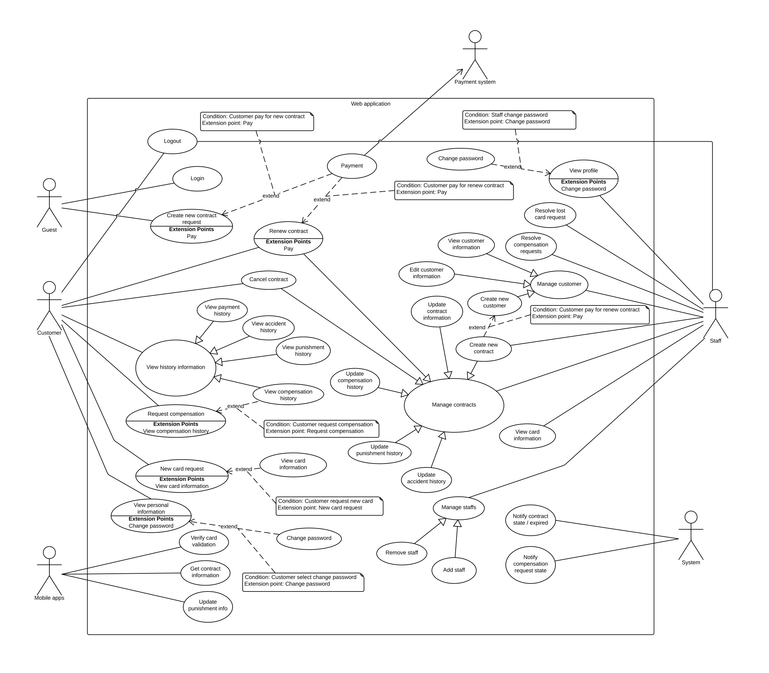

Figure 1 Web Application Overview Use Case

#### Checker Mobile Application

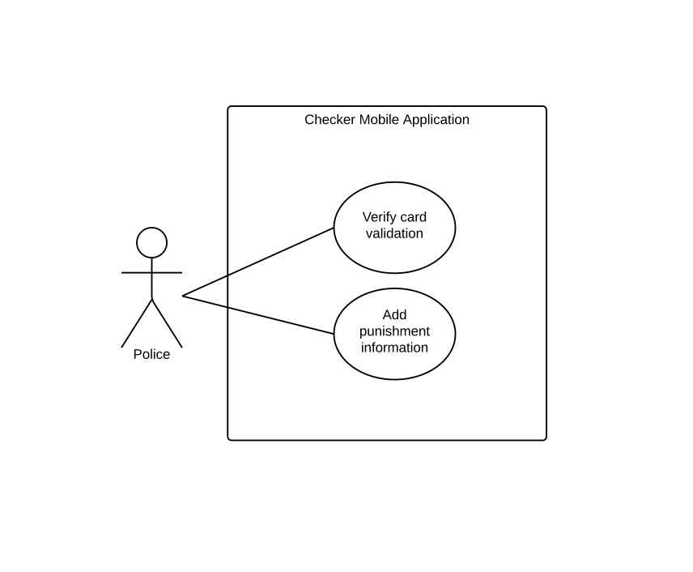

Figure 2 Checker Mobile Application

#### Printer Mobile Application

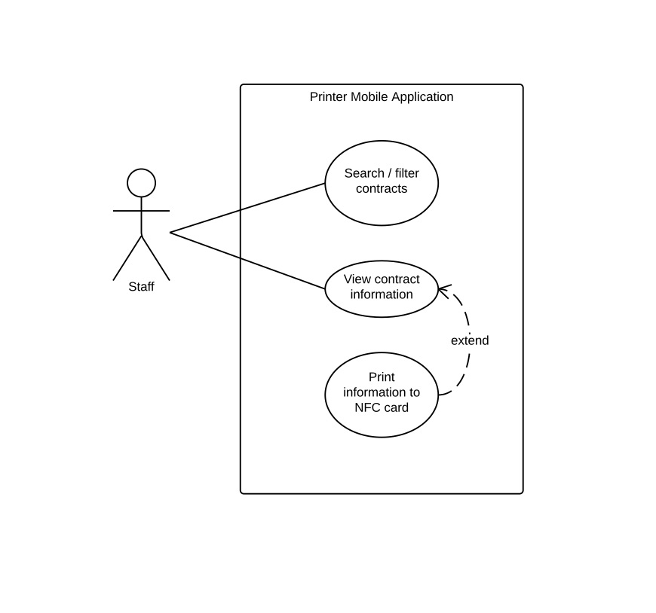

Figure 3 Printer Mobile Application

### List of Use Case

#### Web Application

##### <Guest> Overview Use Case

###### <Guest> Login

<Guest> Create new contract request

##### <Customer> Overview Use Case

###### <Customer> Logout

###### <Customer> Renew contract

###### <Customer> Cancel contract

###### <Customer> View payment history

###### <Customer> View accident history

###### <Customer> View punishment history

###### <Customer> Request compensation

###### <Customer> View compensation history

###### <Customer> New card request

###### <Customer> View card information

###### <Customer> View personal information

###### <Customer> Change password

##### <Staff> Overview Use Case

###### <Staff> View profile

###### <Staff> Change password

###### <Staff> Resolve lost card request

###### <Staff> Resolve compensation

###### <Staff> View customer information

|  |  |  |  |
| --- | --- | --- | --- |
| USE CASE – MIC000 | | | |
| Use Case No. | MIC000 | **Use Case Version** | 2.0 |
| Use Case Name | View customer information | | |
| Author | KhaNC | | |
| Date | 20/05/2015 | **Priority** | Medium |
| Actor:  Staff.  Summary:  This use case allow staff view customer details.  Goal:  Staff can view customer’s detail information.  Triggers:  Staff clicks customer’s code link on customer management page.  Preconditions:  User must login into the system with role Staff.  Post Conditions:  Success: Customer’s detail information is shown.  Fail: Show error message.  Main Success Scenario:   |  |  |  | | --- | --- | --- | | Step | Actor Action | System Response | | 1 | Staff clicks customer’s code link on customer management page. | Customer details page will be shown with following information:  Go back previous page: button  Update customer’s information: button  Customer’s code: label  Customer’s name: label  Customer’s address: label  Customer’s email: label  Customer’s phone: label  Customer’s personal ID: label  View customer card history: button  Request for new card: button  Customer’s NFC tag ID: link  Card’s activated date: label  Card’s most recent access date: label  View card’s access history: link  Create new contract for this customer: button  A list of customer’s contract as grid which show the following information:  Ordinal number: label  Customer’s contract code: link  Customer’s contract type: label  Contract’s start date: label  Contract’s expired date: label  Contract’s status: label |   Alternative Scenario: N/A  Exceptions: N/A  Relationships: Update customer information, delete customer.  Business Rules:  Customer’s detail information is always loaded from database.  Separate customer’s information into 3 parts: personal information, customer NFC tag and customer’s contract for better vision.  Staff can clicks on NFC tag ID link and contract code link to view their detail information.  Contract’s status is colored by different colors. | | | |

###### <Staff> Edit customer information

|  |  |  |  |
| --- | --- | --- | --- |
| USE CASE – MIC000 | | | |
| Use Case No. | MIC000 | **Use Case Version** | 2.0 |
| Use Case Name | Edit customer information | | |
| Author | KhaNC | | |
| Date | 20/05/2015 | **Priority** | Medium |
| Actor:  Staff.  Summary:  This use case allow staff update customer’s information.  Goal:  Customer’s information is updated to the system.  Triggers:  Staff clicks a button allow update customer’s information in customer details page.  Preconditions:  User must login into the system with role Staff.  Customer details page is loaded successfully.  Post Conditions:  Success: Customer’s information is updated. Log file is generated.  Fail: Show error message.  Main Success Scenario:   |  |  |  | | --- | --- | --- | | Step | Actor Action | System Response | | 1 | Staff clicks a button allow update customer’s information in customer details page. | Create customer page is shown with following labels and fields, staff must fill out all required field (have * symbol):  Enter customer’s full name: textbox, max length: 100, required  Enter customer’s address: textbox, max length: 150, required  Enter customer’s email address: textbox, max length: 100, required  Enter customer’s phone number: textbox, min length: 10, max length: 11, required  Enter customer’s personal ID: textbox, length: 9  Update customer’s information: button  Abort this action: button | | 2 | Staff fill out the form. |  | | 3 | Staff click button to update customer’s information.  [Alternative 1] | Validate data  [Exception 1, 2, 3, 4, 5, 6, 7]  Update customer’s information to database.  Refresh customer details page.  Write log file. |   Alternative Scenario:   |  |  |  | | --- | --- | --- | | No | Actor Action | System Response | | 1 | Staff click button to abort this action. | Close modal, abort all changes, return to customer details screen. |   Exceptions:   |  |  |  | | --- | --- | --- | | No | Actor Action | System Response | | 1 | Customer’s full name field is empty | Show message notify staff enter customer’s full name | | 2 | Customer’s address field is empty | Show message notify staff enter customer’s address | | 3 | Customer’s email address field is empty | Show message notify staff enter customer’s email address | | 4 | Customer’s email address field’s value is not a valid email | Show message notify entered email is not valid | | 5 | Customer’s phone number field is empty | Show message notify staff enter customer’s phone number | | 6 | Customer’s phone number field is not a valid phone number | Show message notify entered phone number is not valid | | 7 | Length of customer’s personal ID is different from 9 | Show message notify customer’s personal ID must contains 9 digit. |   Relationships: View customer details.  Business Rules:  In case of success scenarios, customer new information would be updated to database.  Reloaded customer details page will display customer updated information.  An email address must be validated by this regular expression: (Add later)  Exception must not violate. | | | |

###### <Staff> Create new customer

|  |  |  |  |
| --- | --- | --- | --- |
| USE CASE – MIC000 | | | |
| Use Case No. | MIC000 | **Use Case Version** | 2.0 |
| Use Case Name | Create new customer | | |
| Author | KhaNC | | |
| Date | 20/05/2015 | **Priority** | Medium |
| Actor:  Staff.  Summary:  This use case allow staff create new customer.  Goal:  A new customer is added to the system.  Triggers:  Staff clicks a button allow create new customer in customer management page.  Preconditions:  User must login into the system with role Staff.  Customer management page is loaded successfully.  Post Conditions:  Success: New customer is added to the system. Log file is generated.  Fail: Show error message.  Main Success Scenario:   |  |  |  | | --- | --- | --- | | Step | Actor Action | System Response | | 1 | Staff clicks a button allow create new customer in customer management page. | Create customer page is shown with following labels and fields, staff must fill out all required field (have * symbol):  Go back previous page: button  Enter customer’s full name: textbox, max length: 100, required  Enter customer’s address: textbox, max length: 150, required  Enter customer’s email address: textbox, max length: 100, required  Enter customer’s phone number: textbox, min length: 10, max length: 11, required  Enter customer’s personal ID: textbox, length: 9  Create new customer: button | | 2 | Staff fill out the form. |  | | 3 | Staff click button to create new customer.  [Alternative 1] | Validate data  [Exception 1, 2, 3, 4, 5, 6 , 7]  Add new customer’s information to database.  Display create customer success page.  Write log file. |   Alternative Scenario:   |  |  |  | | --- | --- | --- | | No | Actor Action | System Response | | 1 | Staff click button to go back previous page. | Close page, return to customer management screen. |   Exceptions:   |  |  |  | | --- | --- | --- | | No | Actor Action | System Response | | 1 | Customer’s full name field is empty | Show message notify staff enter customer’s full name | | 2 | Customer’s address field is empty | Show message notify staff enter customer’s address | | 3 | Customer’s email address field is empty | Show message notify staff enter customer’s email address | | 4 | Customer’s email address field’s value is not a valid email | Show message notify entered email is not valid | | 5 | Customer’s phone number field is empty | Show message notify staff enter customer’s phone number | | 6 | Customer’s phone number field is not a valid phone number | Show message notify entered phone number is not valid | | 7 | Length of customer’s personal ID is different from 9 | Show message notify customer’s personal ID must contains 9 digit. |   Relationships: View all customer, view customer details, update customer, delete customer.  Business Rules:  In case of success scenarios, a new customer would be added to database.  An email address must be validated by this regular expression: (Add later)  Exception must not violate. | | | |

###### <Staff> Create contract

###### <Staff> Renew contract

###### <Staff> Cancel contract

###### <Staff> Update contract information

###### <Staff> Update compensation history

###### <Staff> Update punishment history

###### <Staff> Update accident history

###### <Staff> View cards information

###### <Staff> Remove staff

###### <Staff> Add staff

##### <Mobile apps> Overview Use Case

###### Verify card validation

###### Get contract information

###### Update punishment info

##### <System> Overview Use Case

###### Notify contract state / expired

###### Notify compensation request state

#### Checker Mobile Application

##### <Police> Overview Use Case

###### Verify card information

###### Add punishment information

#### Printer Mobile Application

##### <Staff> Overview Use Case

###### Search / filter contract

###### View contract information

###### Print information to NFC card

## Software System Attribute

### Usability

### Reliability

### Availability

### Security

### Maintainability

### Portability

### Performance

## Conceptual Diagram